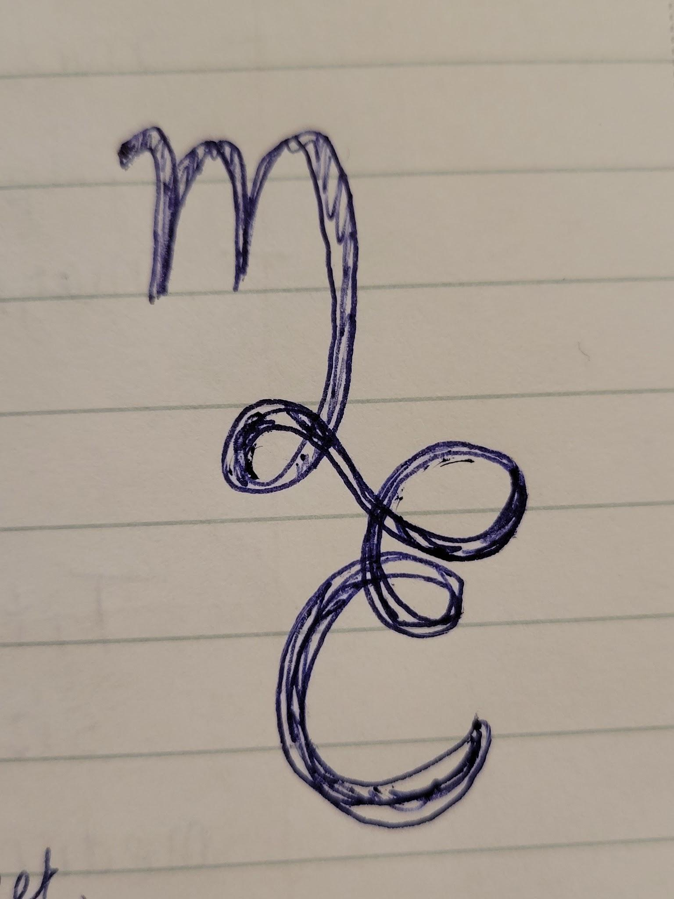
*Thoughts:
Names: margaretedmondsonpaintings.com
MargaretEdmondsonArt.com
MargaretEdmondsonStudio.com

-listed below are pictures that I have taken with my phone to identify the art work. So they are not necessarily high quality images like the scans I previously uploaded.
-I have read it often helps to include multiple pictures of the artwork so that is why I included different angles. All of the pictures are from my google account if there is a better way to share please let me know.
-Also, a random idea that popped into my head is I could stand in a field and hold the artwork in front of me if that would be different, dramatic, funny, or helpful to people.
—---------------------------------------------
TEMPLATE
File Name: Title: Year:
Category:
Medium:
Size
Frame:
For Sale:
Prints:
Description:
—---------------------------------------------------------------------------------------------------

Cactus Themed Paintings:
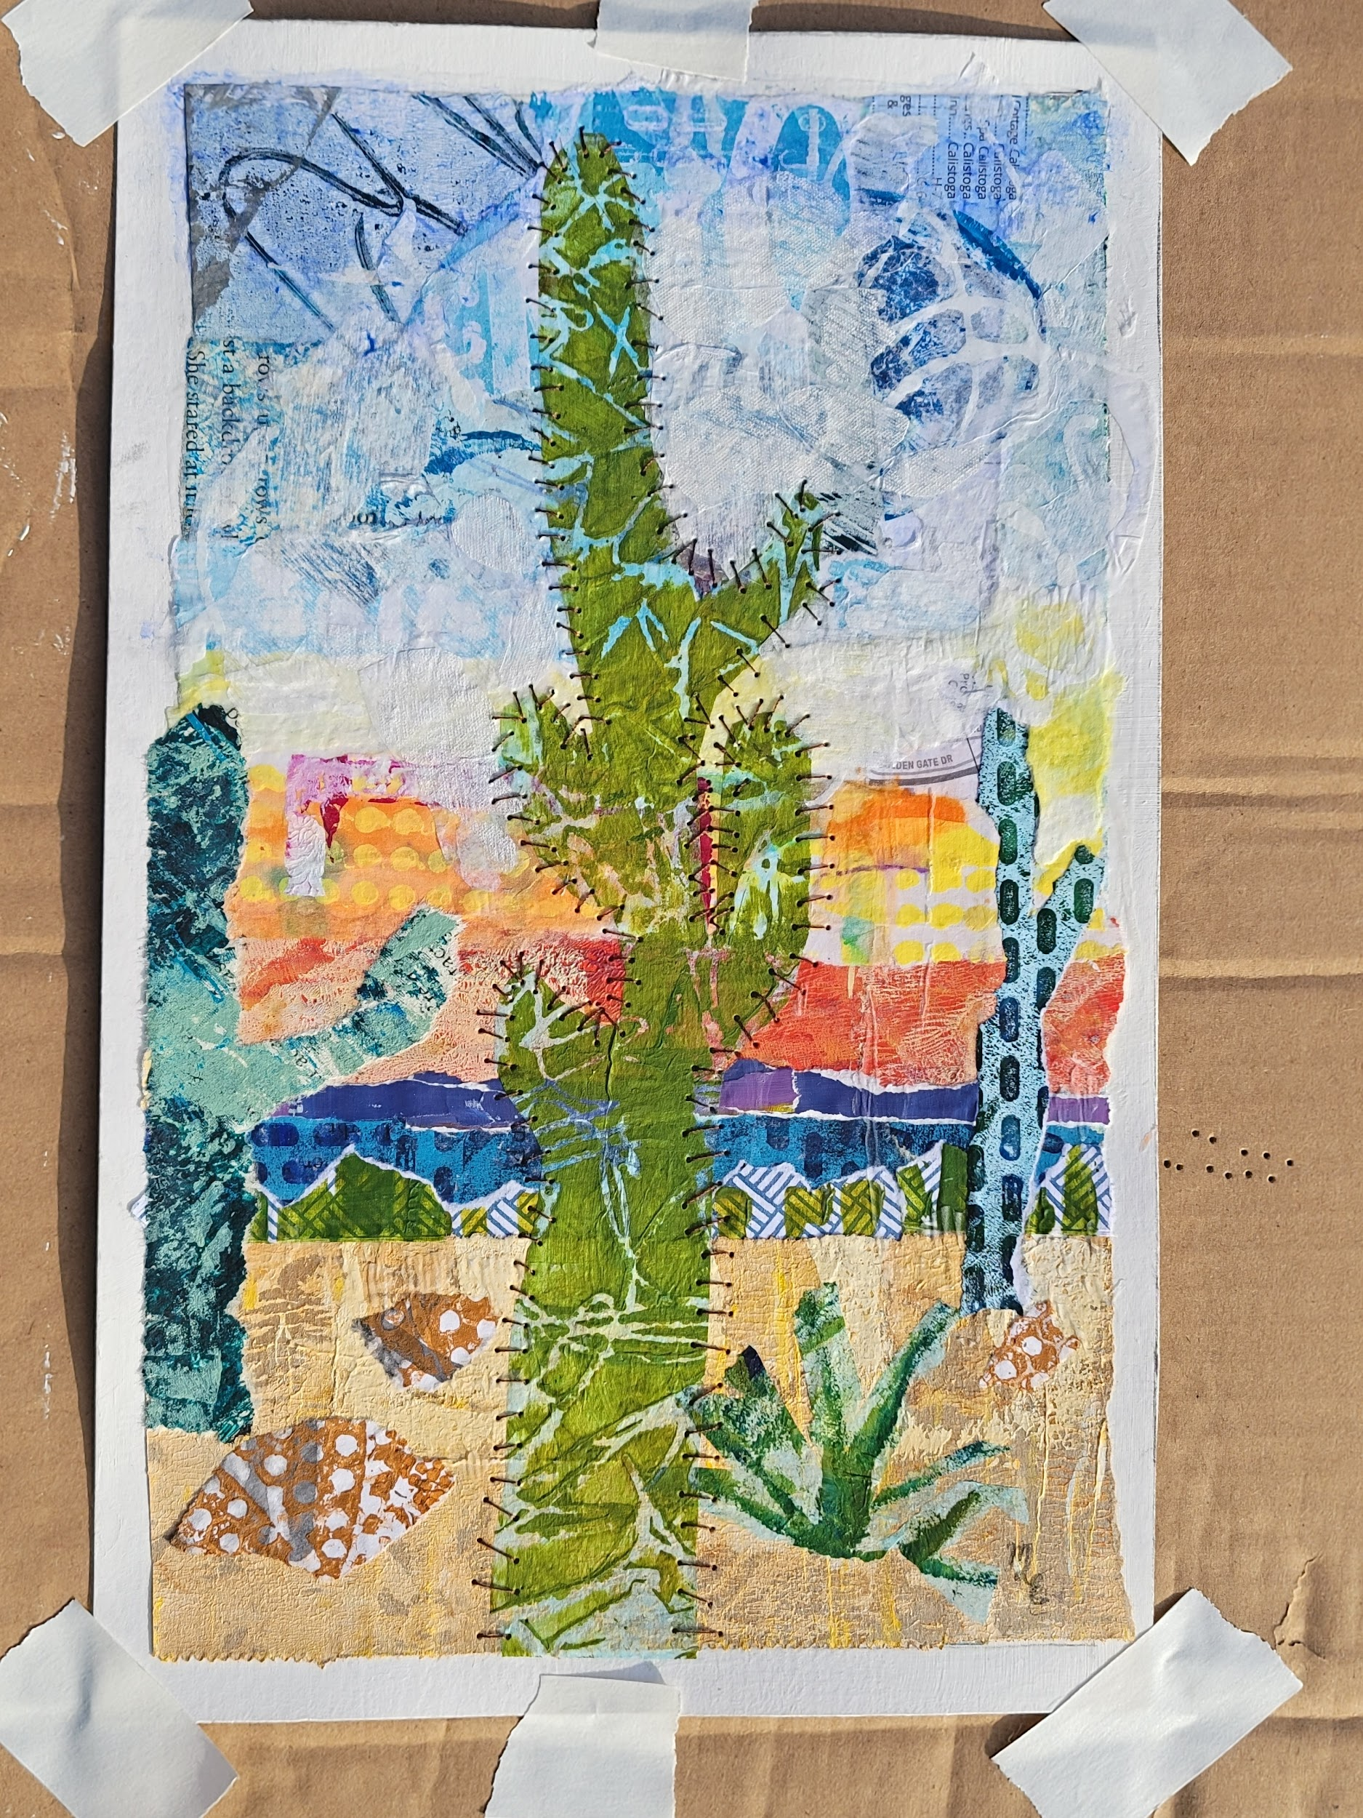
File Name: Title: Pins and Needles Year: 2025
Category: Mixed media
Medium: collage (painted papers and thread)
Size: 6 x 10 inches
Frame: needs a matte, frame
For Sale: yes, $95? Or $115
Prints: yes, on paper, poster, maybe canvas? On any of these custom sizes it would likely make the most sense if a white border is added around them to make them a standard size? Not sure if that is possible. That would allow a buyer to purchase it as a poster for example and place it in a frame if they didn’t want to add the cost of a matte. Not sure how all of this works for specifications.
Description: Memory and familiarity as well as texture and color guided my decision making on this piece. I used painted papers as well as gelli printed papers to experiment with this landscape featuring saguaro cactuses. Cutting, tearing and layering were utilized to create an Arizona fusion piece of art. The final touch was using a needle and thread to simulate the cactus needles in the foreground.
—--------------------------------------------------------------------------------------------------------------

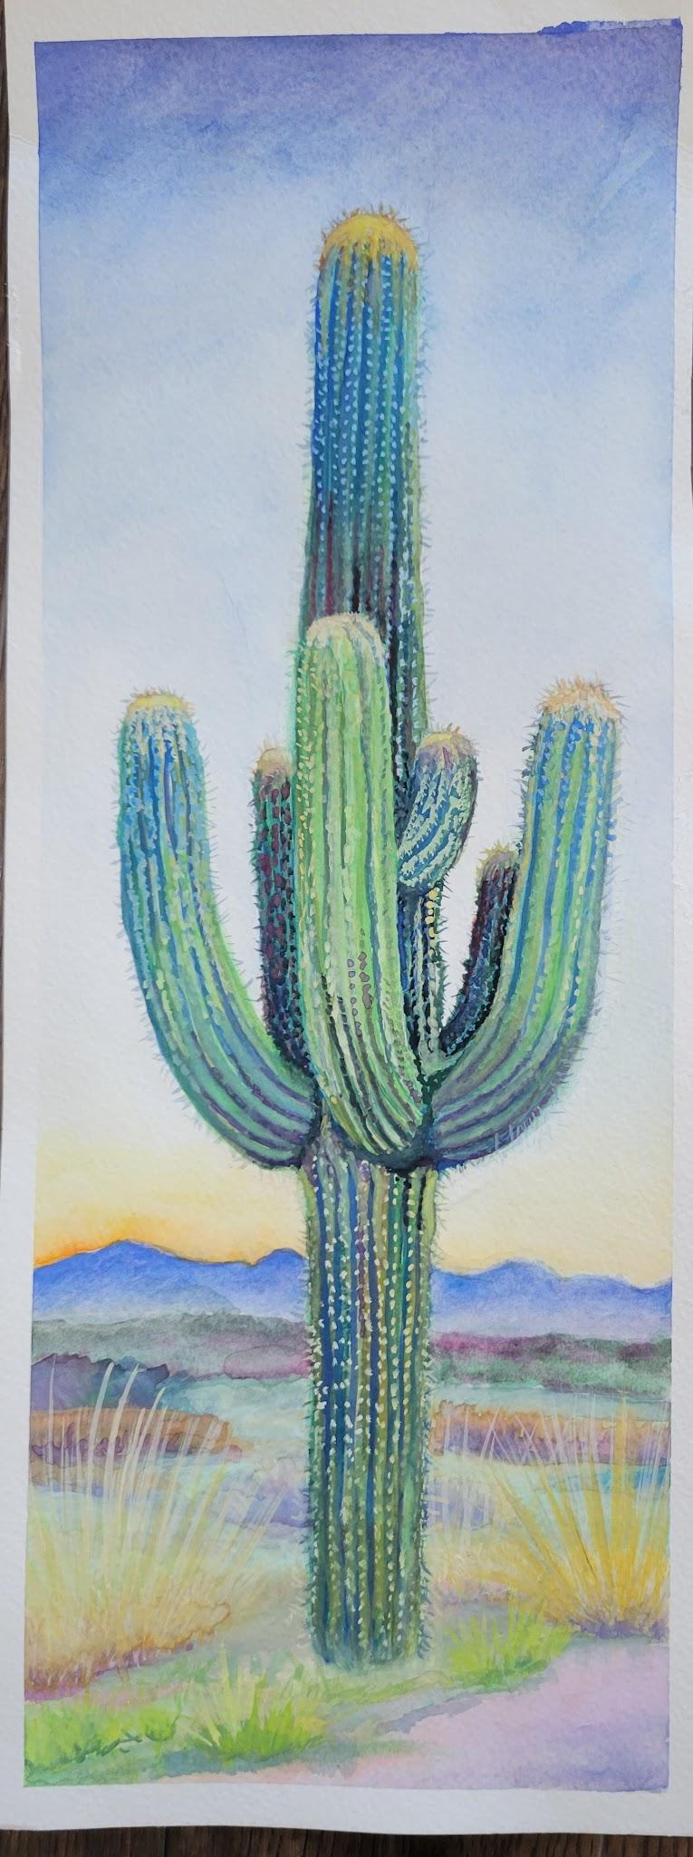
File Name: Title: Sometime Year: 2024
Category: Painting
Medium: water gouache on paper
Size: 6 x 16.75
Frame:
Original For Sale: no…
Prints: yes, paper, poster, could be printed on canvas? Custom size so may need white border around it.
Description: I have visited Arizona only twice and in the last three years, ironically for a soccer tournament and a college tour for my kids, and both times I was in awe of the beauty. The colors I saw were an artist's heaven, the gradations of light in the sky, with the contrast of the sage green crazy unique saguaro cactus. The blue-violet rugged mountains along the horizon that as you turn the mountains continue in a ring around you. The peaches in the sandy soil are thrown in with dabbles of rust copper browns in the rock formations. It felt like I was either on another planet or some underworld, under the sea. I walked and took as many photos as I could in the short visit in Phoenix and another 2 day visit in Tucson that I could. Each cactus has its own personality to me and they are so tall! It is like they are trying to touch the sky! This one is elegant, regal, confident and proud.
—-----------------------------------------------------------------------------------------------------

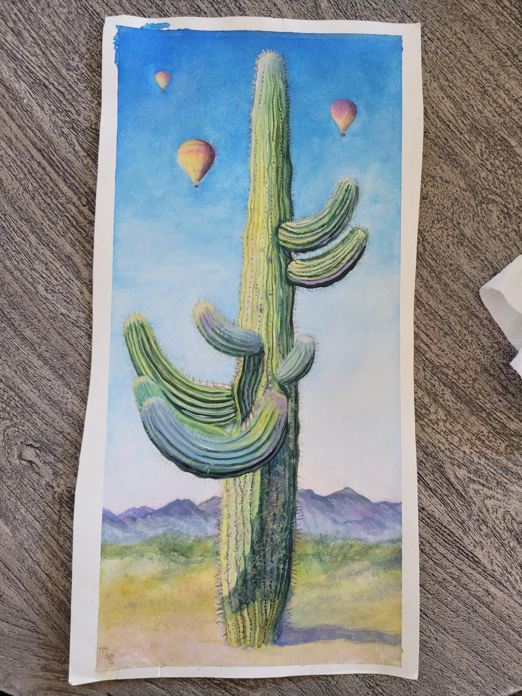
File Name: Title: Hot Air II Year: 2025
Category: Painting
Medium: water gouache on paper
Size: 8 x 17 inches
Frame: needs matte and frame
For Sale: yes, with a custom matt and frame probably $395. A little less because it is a little smaller than the others. It currently does not have a matte or frame. And it is not the same size as the others.
Prints: yes, paper, poster, optional canvas
Description: I have visited Arizona only twice and in the last three years, ironically for a soccer tournament and a college tour for my kids, and both times I was in awe of the beauty. The colors I saw were an artist's heaven, the gradations of light in the sky, with the contrast of the sage green of the unique saguaro cactuses. The blue-violet rugged mountains along the horizons, the peaches in the sandy soil thrown in with dabbles of rust copper browns in the rock formations. The cactuses often seemed so human-like, amusing and fascinating to me. It felt like I was either on another planet or some underworld, under the sea. I walked and took as many photos as I could in the short 3 day visit in Phoenix and another 2 day visit in Tucson that I could. In the great expanse of the sky I saw hot air balloons and this cactus was ready for them.
—--------------------------------------------------------------

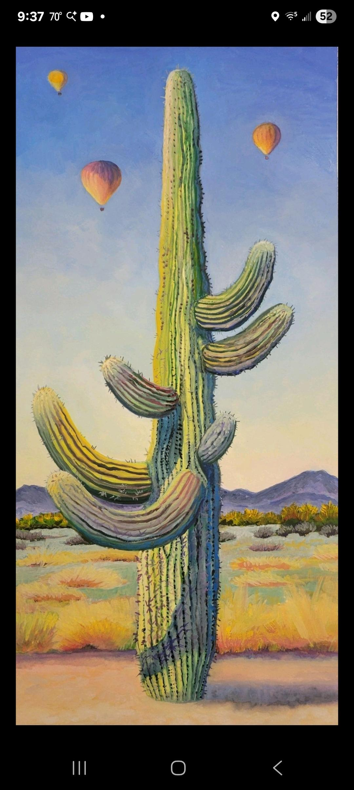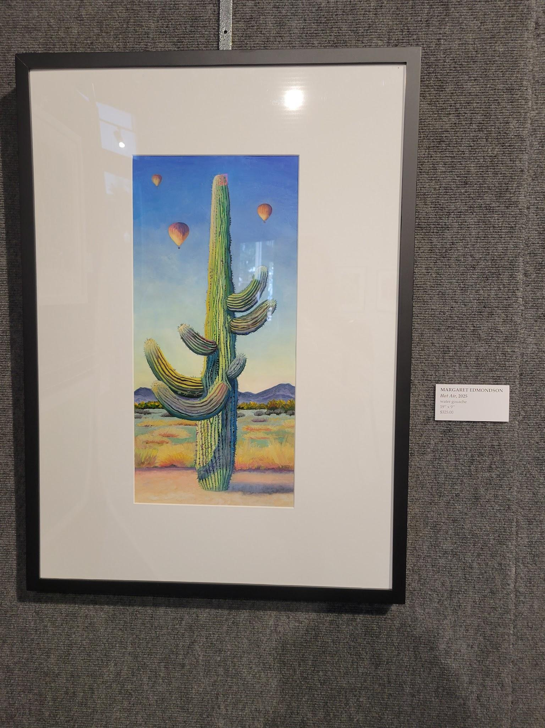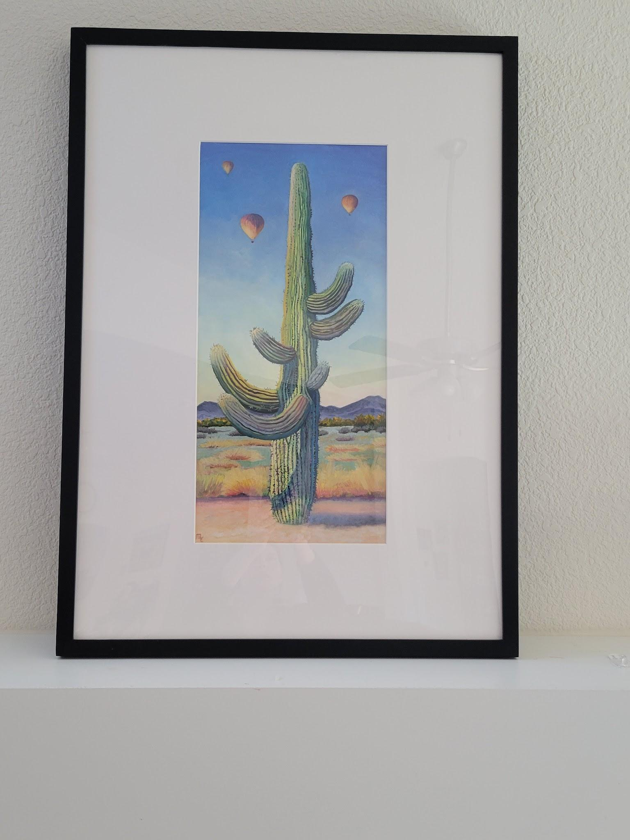
File Name: Title: Hot Air Year: 2025
Category: Painting
Medium: water gouache on paper
Size: 9 x 19 inches
Frame: white matte, black frame final framed size 20 x 28
For Sale: yes $450.
Prints: yes
Description: I have visited Arizona only twice and in the last three years, ironically for a soccer tournament and a college tour for my kids, and both times I was in awe of the beauty. The colors I saw were an artist's heaven, the gradations of light in the sky, with the contrast of the sage green of the unique saguaro cactuses. The blue-violet rugged mountains along the horizons, the peaches in the sandy soil thrown in with dabbles of rust copper browns in the rock formations. The cactuses often seemed so human-like, amusing and fascinating to me. It felt like I was either on another planet or some underworld, under the sea. I walked and took as many photos as I could in the short 3 day visit in Phoenix and another 2 day visit in Tucson that I could. In the great expanse of the sky I saw hot air balloons. This cactus is ready for them.
—-----------------------------------------------------------------------

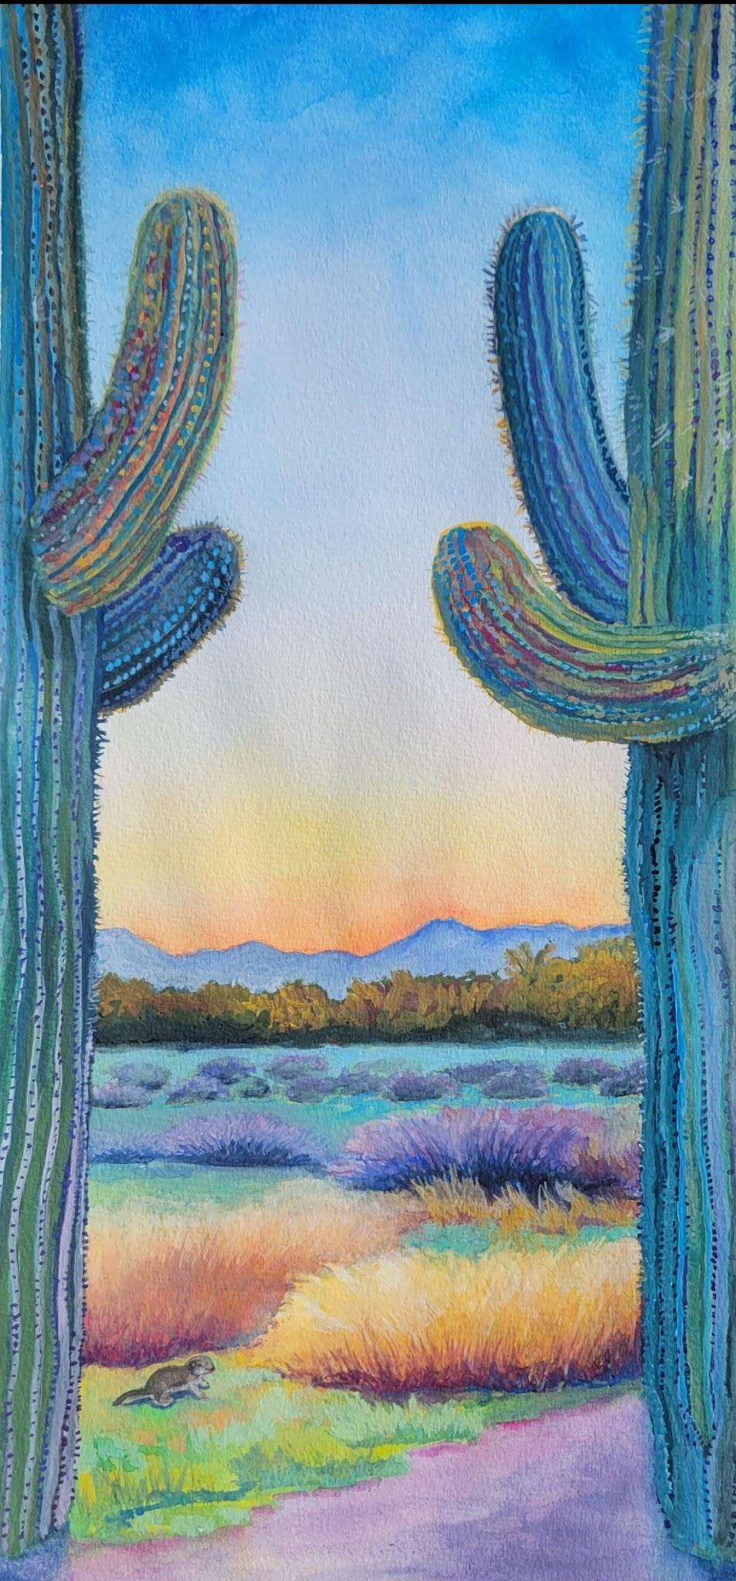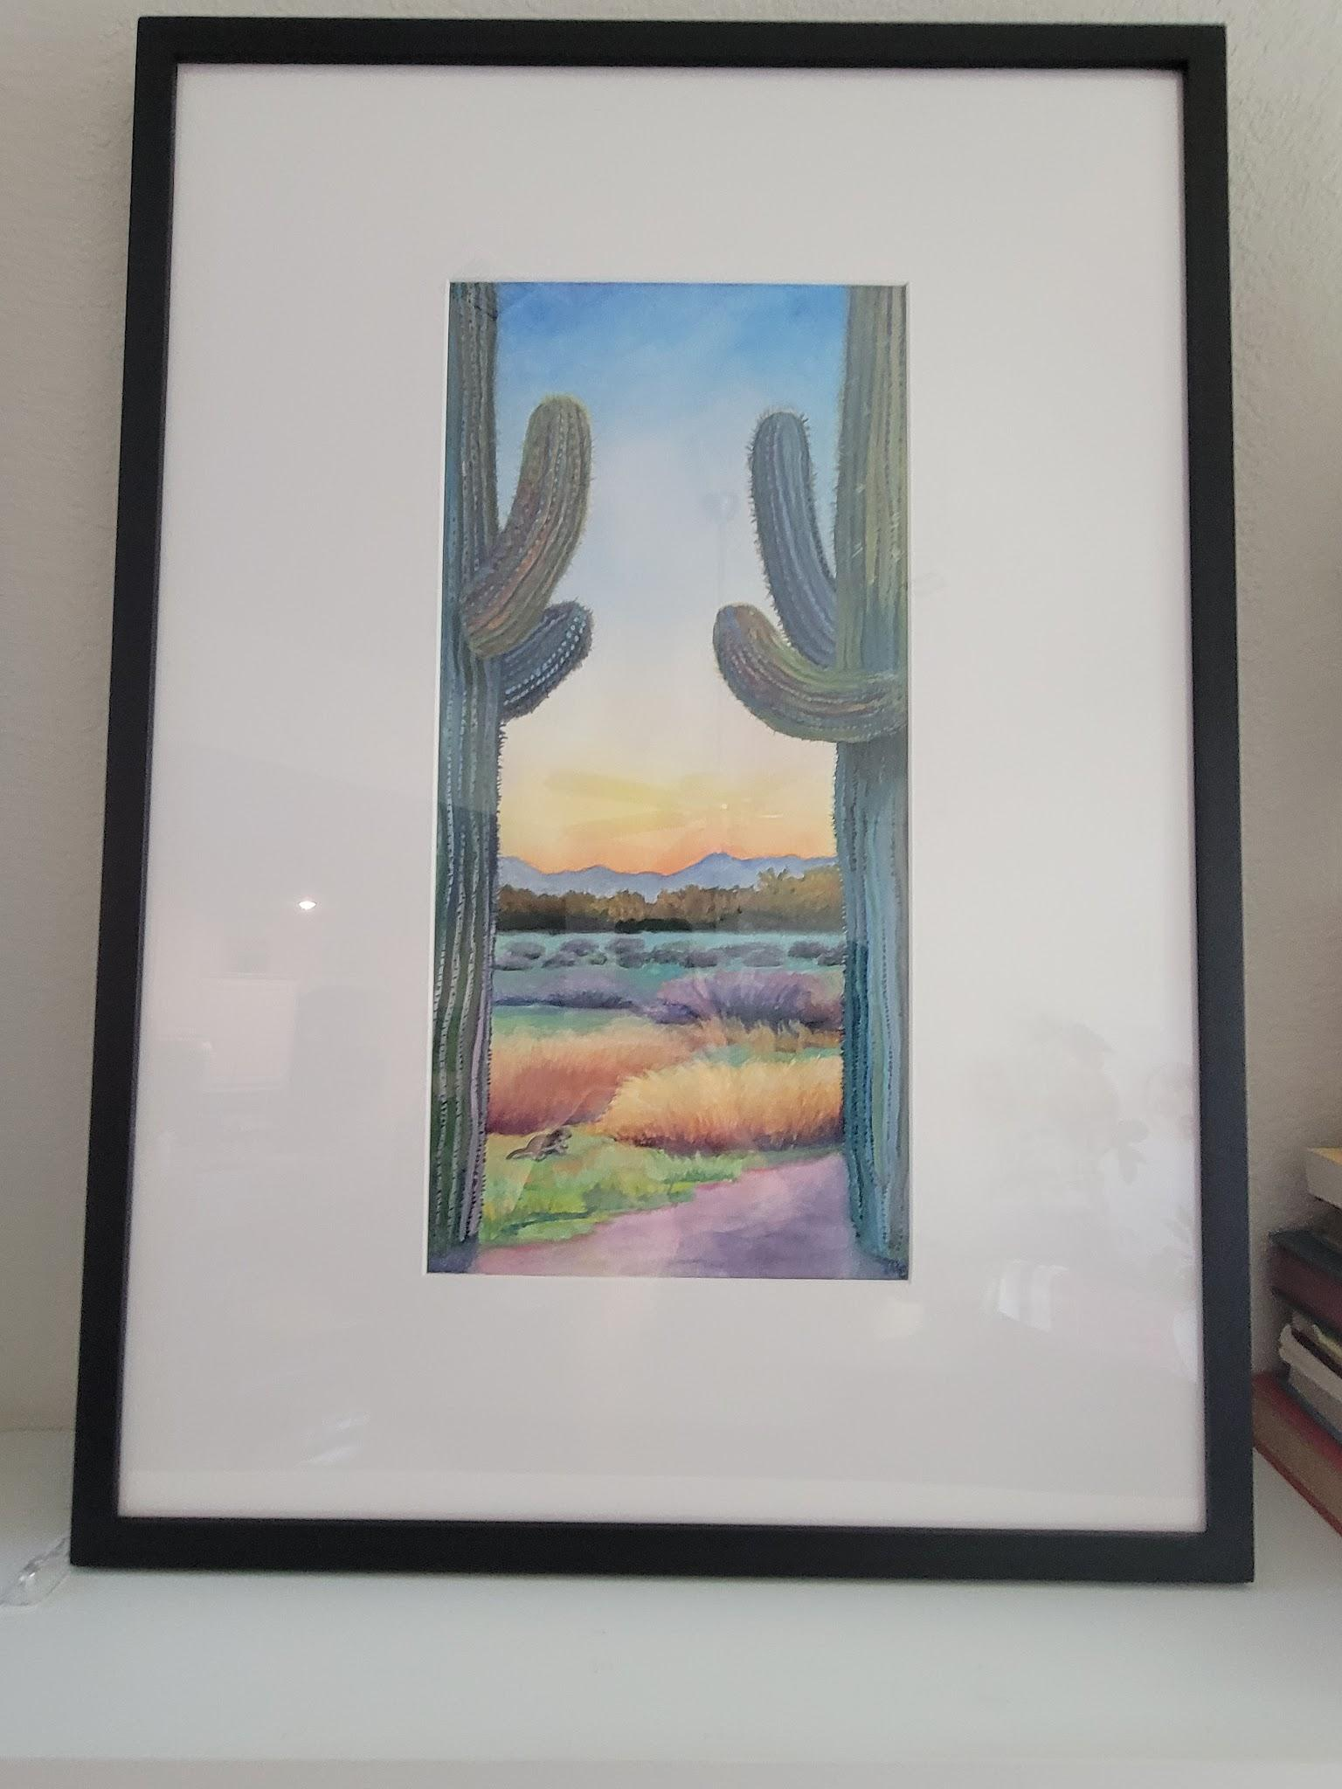
File Name: Title: The Dual Year: 2025
Category: Painting
Medium: water gouache on paper
Size: 9 x 19
Frame: yes, white matte and black frame, final framed size 20 x 28
For Sale: yes, same size sold for $450, but I don’t think this piece is as strong, so maybe $395? Or less?
Prints: yes
Description: I have visited Arizona only twice and in the last three years, ironically for a soccer tournament and a college tour for my kids, and both times I was in awe of the beauty. The colors I saw were an artist's heaven, the gradations of light in the sky, with the contrast of the sage green of the unique saguaro cactuses. The blue-violet rugged mountains along the horizons, the peaches in the sandy soil thrown in with dabbles of rust copper browns in the rock formations. The cactuses often seemed so human-like, amusing and fascinating to me. It felt like I was either on another planet or some underworld, under the sea. I walked and took as many photos as I could in the short 3 day visit in Phoenix and another 2 day visit in Tucson that I could. In this piece I felt like the cactuses were duking it out as witnessed by a ground squirrel scampering below.

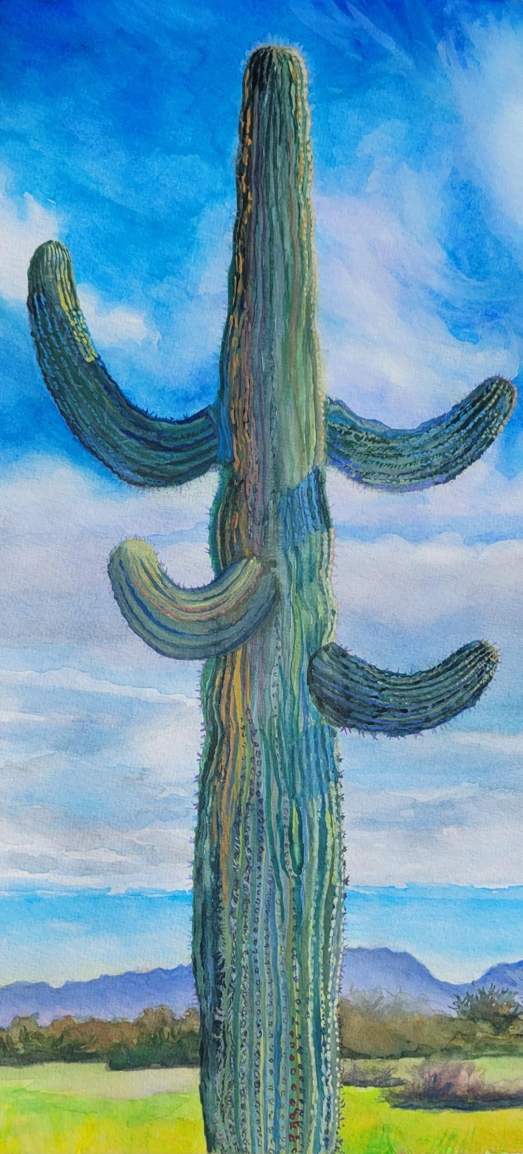
This piece is sold and I do not have a professional scan of it. I did receive the merchant award at an art show for it as listed on my CV page. Some artists have their award piece linked to the CV page. “Solo”. It was the size of some of the other cactus paintings and sold for $450. Gallery took 30 % and there was a fee to enter the show. It was custom matted and framed, sigh, so I really didn’t hardly make anything. But, we know that that is a selling price for paintings similar to these. Could have a “SOLD” sign over it and maybe have the ability to make smaller prints of it or cards. Like a multi box of cactus greeting cards? Shows I have been sticking with a theme working on a series…?
It is irregular and like a juggler in a peaceful, cool colored landscape.

